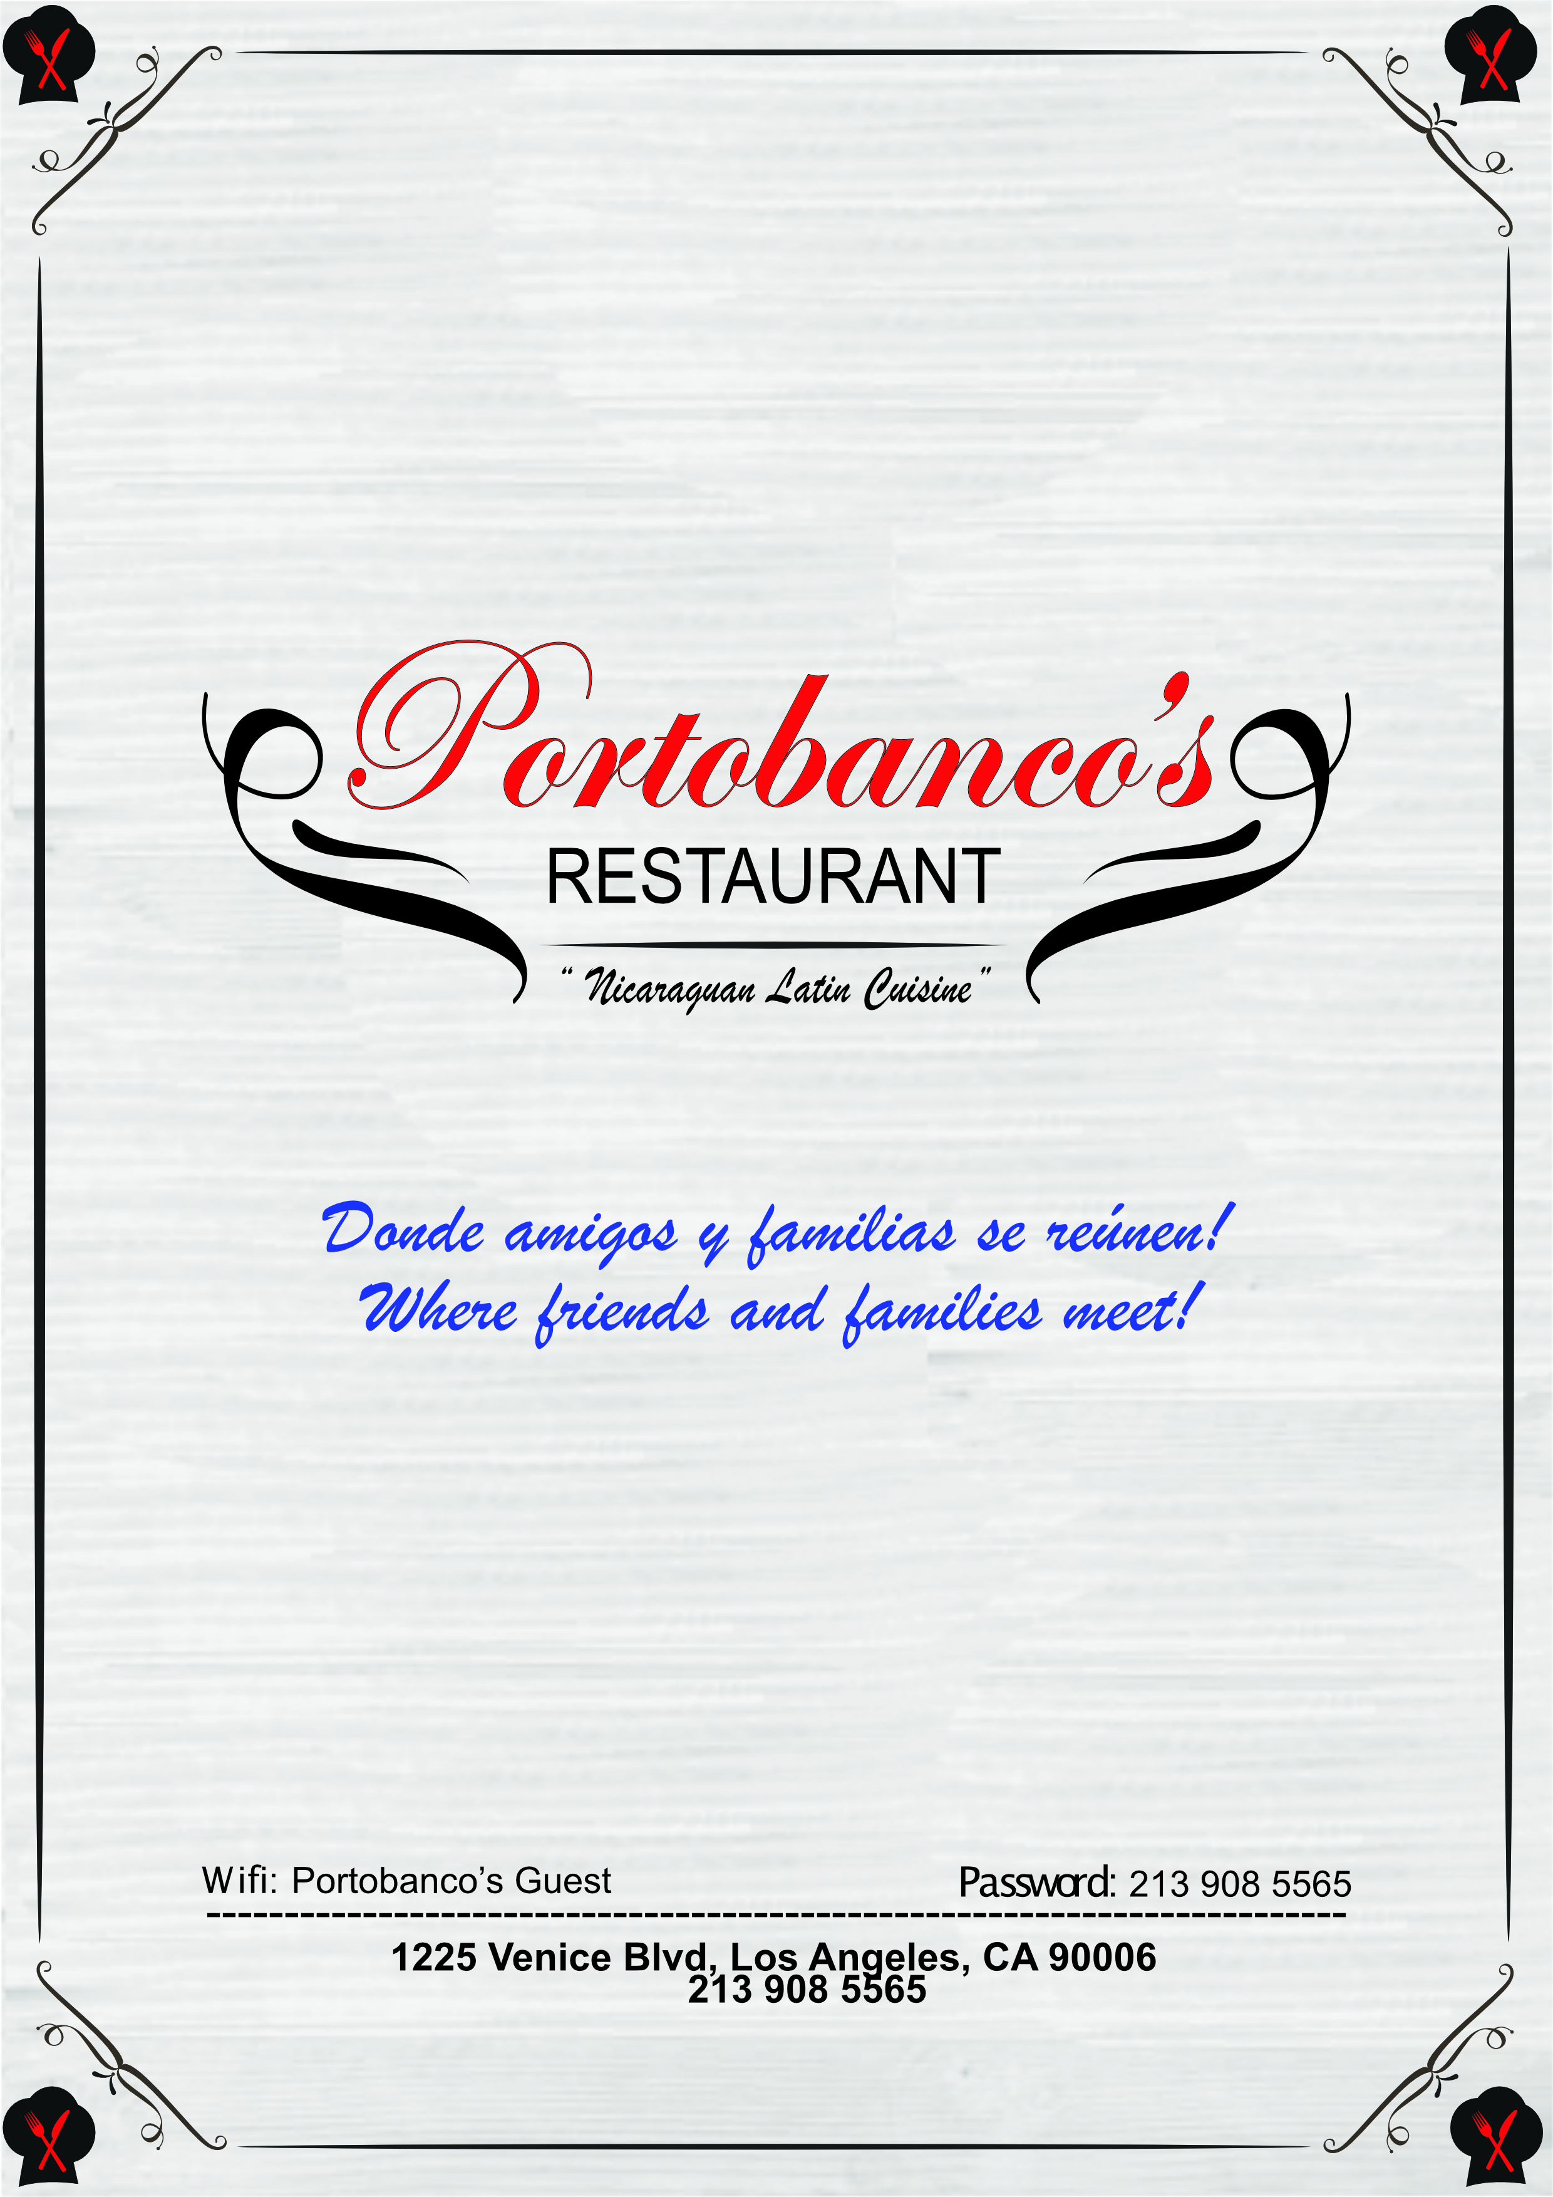



Platos típicos / Cultural dishes

NACATAMAL.....………...……………............………………………................................................ 6.95

(Masa de maíz rellena con carne de cerdo, arroz, papa, tomate, cebolla y chile / Corn dough

filled up with small pieces of pork, rice, potatoes, tomatoes, onion and pepper all in slices)

VIGORÓN.....………...…………………………...........................................……..........................…. 8.95

(Originario de Granada, este plato tradicional está conformado de yuca, chicharrón, y

ensalada / Originally from Granada, this traditional plate is made of yucca, fried pork and

a salad made of cabbage and tomato)

CHANCHO CON YUCA.....………...……….........………………………............................……..... 9.95

(Plato típico servido en todo Nicaragua compuesto de carne de cerdo frita con yuca y

ensalada / Fried pork dish accompanied with yucca and salad)

POLLO AL HORNO.....………...……….........……………………….........................……................ 12.95

(Pollo al horno con cebollas acompañado de arroz, frijoles y maduros / Half roasted chicken

with onions served with rice, beans and sweet plantains)

CARNE ASADA.....………...……….......................................……............………………………...... 13.95

(Carne asada acompañada con arroz, frijoles, tajadas, ensalada y queso / Roasted beef

accompanied with beans, rice, green plantains, cheese and salad finely cut)

BAHO.....………...………………………………............................................................................….. 14.95

(Carne al vapor con plátanos / Steamed beef and plantains)

FRITANGA.....………...………...................................……………………….........................……...... 16.95

(Carne de res, cerdo y chorizo acompañada con gallopinto, ensalada, queso y maduro o

tajadas / Beef, pork and sausage accompanied with rice and beans mix, salad, cheese and

sweet plantains or green plantains)

PARRILLADA.....………...…….................................……………………….........................……...... 39.95

(Carne de res, cerdo, chorizo, camarón y pollo acompañada con gallopinto, ensalada, queso,

maduro y tajadas / Beef, pork, chicken, shrimp and sausage accompanied with rice and

beans mix, salad, cheese, sweet plantains and green plantains)



Aperitivos / Appetizers

TOSTONES RELLENOS

(Plátanos verdes dorados rellenos con / Green Golden plantains filled with)

Queso / Cheese (6) ………………………………………………………………………………………….....……………… 6.95

Carne / Beef – Pollo / Chicken (4) ……………………………………………………………………..……….....……. 7.95

Camarones / Shrimp (4) …………………………………………………………………………………................….... 8.95

TAQUITOS NICARAGUENSES……………………………………………………………..........……….. 6.95

(Taquitos de pollo o res acompañados con repollo y crema / Corn tortillas rolled up with

chicken or beef accompanied with cream and cabbage)

BOLITAS DE CARNE………...….…………………………………………..........…………………………...... 7.95

(Bolitas de carne acompañadas con ensalada de tomate / Small beef meatballs

accompanied with tomato salad sprinkled with a touch of salt)

CALAMARES FRITOS……...….............…………………………………………………………………….... 11.95

(Calamares acompañados con curtido de cebolla roja / Calamari accompanied with red onions)

Extras / Sides

s

TOSTONES...........................…………………………………..................………………………….……….. 1.00

GALLO PINTO / RICE AND BEANS MIX............……………….......……………….…....... 2.95

QUESO / CHEESE……………………………..............…………………………......……….…….……....... 2.95

QUESO / CHEESE……………………………..............…………………………......……….…….……....... 2.95

MADURO / PLANTAIN…………………..............…………………………......……….….………....... 2.95

ENSALADA / SALAD……………………………..............……………………......……….….………....... 2.95

ARROZ / RICE……………………………..............……………………………….............….….………....... 2.95

FRIJOLES / BEANS…………………….……..............……………………………......……..…………....... 2.95

CREMA / CREAM……………………………..............……………………………......……..…………....... 1.50



Bebidas / Drinks

CACAO…...........................……….……………………………...........…………………….......…………...... 3.95

CHIA CON TAMARINDO............………………………………………….…………………................ 3.95

MARACUYA……………………………..............………………………….........……….…………................ 3.95

PITAYA……………………………..............………............……………….......………….……….........…....... 3.95

DRINKS / SODAS…………………..............………..........………………………….……….........…....... 2.00

AGUA / WATER……………………………..............……….......…………………….……….........…....... 1.95

Postres / Desserts

BUÑUELOS.....………...…………………............................…………….........................…............... 3.95

(Buñuelos de yuca crujientes con canela y queso acompañados de miel / Deep fried

yucca & cheese balls topped with cinnamon and honey)

ARROZ CON LECHE.....……….............……….........………………………..........................…….... 3.95

(Arroz con leche y canela en polvo / Rice pudding with sprinkle of cinnamon)

PIO QUINTO.....………...………....................…..……………………....................................……..... 3.95

(Postre Nicaragüense que consta de bizcocho, miel y atol / Cake drenched in rum syrup, topped with a custard, with honey and atole)

TRES LECHES.....………...……………………………….................................................................... 3.95

(Torta casera de tres leches / Home made three milks sponge cake)

